

Swami: The Next Generation Biology Workbench

Swami Code Generation

Subject
This document describes the specification and the implementation of the SWAMI code generation for the input parameters with Struts/JSP framework and the Unix command line.
Change History

Author | Date | Version | Comments
Rami Rifaieh | 02/22/07 | V01 | Creation
Jeremy Carver | 03/14/07 | V02 | Add Section 2.1
Rami Rifaieh | 03/17/07 | V03 | Sections Additions (1, 2, 3)
Mark Miller | 04/23/07 | V04 | Add Annex C
Jeremy Carver | 04/30/07 | V02 | Update Section 2.1
Jeremy Carver | 7/13/07 |  | Update Section 2.1

Contents
1 Introduction 5
1.1 Problem 5
1.2 PISE XML 5
2 Struts/JSP code generation 6
2.1 Specifications 6
2.2 Implementation 20
3 Unix Command Line Generation 22
3.1 Specification and Design 22
3.2 Implementation 24
4 References: 25

Introduction
SWAMI (the new generation of Biology Workbench) provides a set bioinformatics tools to be available for user community. There exist hundreds of biology tools that a workbench user would be interested in using. Each one of these tools has a set of parameters that a user can change and modify.

Problem
The NGBW tries to provide a user-friendly environment where all the technical details hidden from the user interface. In consequent, users will not be affected by the DB storage, machine configuration, tools installation, etc. In addition, we need to create a set of interfaces that deliver bioinformatics tools without showing any technical details (where the tools is installed, which directories is being used, which Unix command is being used, delete temporary files, save outputs, etc.).

Furthermore, we have to study individually each tool in order to identify the set of parameters associated with that tool and find all the values (by default) and their conditions, and finally associate the correct command line to a given set of parameters.

After reviewing existing approaches for tackling these issues, we identified PISE as a possible solution.

PISE XML
PISE (Pasteur Institute Software Environment) is an abstract definition of a program’s parameters [1]. It can be used to generate Web-based interface for interacting with command line tools. PISE XML provides a generic description using XML syntax in addition to Perl statements to evaluate conditions and tests. The deployment of PISE as distributed would impose using Perl/CGI architecture on our web application. Therefore, we have chosen to use uniquely the 300+ tool descriptions given by PISE XML files without deploying the entire environment.

The use of PISE XML in SWAMI is resumed in two points (Figure 1):
- Using tools’ definitions to create Web Artifacts compatible with SWAMI web Application (Struts/JSP). This will enable users to use forms to enter the values associated with each parameter.
- Using Tools’ definitions and user’ entered parameters’ values to generate a command line that will execute the tool.

The reminder of this document describes in detail the technical issues involved in theses two points.

N.B: The latest PISE distribution is 5.a [2] includes the definitions of 370 tools. However, these definitions have a number of syntactical mistakes that we have faced in our use. The description of these errors and their possible corrections are given in the Appendix A.

Figure 1. The general description of the use of PISE XML in the Workbench

Struts/JSP code generation
Swami implements a web application by using Struts 2.0/JSP Frameworks, the artifact needed for handling the input of the parameters associated with each tool are described in the specifications (section 2.1).

Since PISE XML distribution includes ~370 tools, we tried to find a simplified procedure to generate the Struts/JSP artifact need for these tools. Indeed, for each tool we need: 1 new JSP file, 1 new Action class, 2 entries in Struts.xml, 1 entry in Validation.xml. The total becomes: 370*2= 740 files and 370*2 = 740 updates. All of these files and updates should be done only one time, during the development of the web application.

Done by hand, the process is repetitive, time consuming and error prone. Therefore, we have tried to identify an automatic procedure that can replace the developer in charge of creating these artifacts. The description of this procedure and its implementation is given in (section 2.2).

Specifications
These are the components that need to be generated for each new tool that is added to the workbench. See below for specific details on each component.

These are the components that need to be generated for each new tool that is added to the workbench. See below for specific details on each component.

Change Log

4/24/07

Component 2 – Action mapping
- Changed body of first result tag (name=”success”) from “task!input” to “createTask!input”.
- Changed body of second result tag (name=”input”) from “ToolName” to “taskForm”. This tag body is now static and not tool-dependent.

Component 3 – Action class
- Removed FormFile class import, no longer used in this action class.
- Changed UserData import to “org.ngbw.api.userdata.UserDataItem”.
- Changed primitive property getters and setters to interface properly with the new parameter map, which only holds Strings.
- Changed file property getters and setters to interface properly with the new input data items map. Users will no longer upload files directly on this page.

Component 4 – Tiles definition
- This component has been removed completely. It is no longer necessary.

Component 5 (now 4) – Tool parameter JSP
- Changed section header tags to be h3’s rather than h2’s, to more properly suit the application’s look and feel.
- Changed form tag to remove the “method” and “enctype” attributes, which were only necessary to accommodate the file upload process. Added ‘theme=”simple”’ attribute to more properly suit the look and feel.
- Moved submit buttons to the end of the form, changed their text to be static and not tool-dependent, added a “Cancel” button, and added some line breaks and a horizontal rule to this block for cosmetic reasons.
- Changed all form widget templates to add a <br/> tag at the end. Without this, the whole form will appear on one line.
- Changed all form widget templates to move their labels outside the tag, since the “label” attribute does not output properly in the “simple” theme.
- Changed “radio” and “select” tag templates to fit their proper usage. Both must define their lists in the same manner.

4/25/07

Component 3 – Action class
- Added proper functionality for converting array-typed parameters to and from regular Strings.
- Added proper functionality for retrieving file-typed parameters from the user interface, which selects by ID.

Component 4 – Tool parameter JSP
- Reversed the order of “select” and “radio” tag values and labels. The values are supposed to come first.

4/30/07

Component 3 – Action class
- Changed the way in which non-String properties are dealt with as opposed to String properties. Non-String properties must be properly cast to and from Strings in both the getters and setters, or else the form will not be properly pre-populated.

5/1/07

Component 2 – Action mapping
- Changed the “success” result for each tool-specific action mapping. It is no longer a “redirect-action”, but simply points straight to the proper result page. This is because Struts will not properly copy the attributes of an action when you redirect, so important confirmation message information is lost if you do it the old way.
7/13/07

Component 3 – Action class
- Removed special method templates for Integer and Double typed properties. All properties should now be Strings, except for multiple-selectable drop-down lists (Array type), and UserDataItem parameters.

Component 5 – Validation class
- Removed the Struts validator XML configuration file completely, and replaced it with a Java validation class, to allow business-level validation of tool parameters outside the context of the Struts web application.
These are the components that need to be generated for each new tool that is added to the workbench. See below for specific details on each component.

1 Global result
for tool parameter action
in struts.xml
2 Action mapping
to process parameters
in struts.xml

3 Action class
in package
org.ngbw.web.actions.tool
4 Tool parameter JSP
in directory /pages/tool/
under webapp
5 Validation class

in package
org.ngbw.sdk.pise.tool
Black text indicates static code that is present before any new tools are added, and is not affected by the addition of new tools.

Blue text indicates non-tool-specific code that is added for each new tool. This code is the same for each tool that is added.

Red text indicates tool-specific code that is added for each new tool. This code will have to be adapted to fit the name or parameter content of the tool to which it applies.

struts.xml

<package …>
…

…

…
</package>
1 <global-results>
…
<result name=”ToolName” type=”redirect-action”>
ToolName!input
</result>
…
</global-results>
2 <action name=”ToolName”
class=”org.ngbw.web.actions.tool.ToolName”>
<result name=”success”>taskForm</result>
<result name=”input”>taskForm</result>
</action>

org.ngbw.web.actions.tool.ToolName

3 package org.ngbw.web.actions.tool;

import org.ngbw.sdk.api.userdata.UserDataItem;
import org.ngbw.sdk.common.util.SuperString;

@SuppressWarnings(“serial”)
public class ToolName extends ToolParameters
{

public String getProperty() {
return getToolParameters().get(“Property”);
}
public void setProperty(String Property) {
getToolParameters().put(“Property”, Property);
}

...

public String[] getArrayProperty() {
String value = getToolParameters().get(“ArrayProperty”);
return SuperString.valueOf(value, ‘ ‘).toArray();
}
public void setArrayProperty(String[] ArrayProperty) {
String value = SuperString.valueOf(ArrayProperty, ‘ ‘).toString();
getToolParameters().put(“ArrayProperty”, value);
}

...

org.ngbw.web.actions.tool.ToolName (continued)

3 public Long getFileProperty() {
return ((UserDataItem)getInputDataItems().get(“FileProperty”))
.getId();
}
public void setFileProperty(Long FileProperty) {
UserDataItem dataItem = getSelectedData(FileProperty);
getInputDataItems().put(“FileProperty”, dataItem);
}

...

protected void reset() {
super.reset();
setProperty1(Property1DefaultValue);
setProperty2(Property2DefaultValue);
…
}
}

/pages/tool/ToolName.jsp

4 <%@ taglib prefix=”s” uri="/struts-tags” %>

<h2>ToolName Parameters</h2>

<s:form action=”ToolName" theme=”simple”>

<br/><hr/>
<h3>Section 1 Header</h3>
Field1
Field2
…

<br/><hr/>
<h3>Section 2 Header</h3>
Field1
Field2
…

…

<br/><hr/><br/>
<s:submit value=”Save Parameters”/>
<s:submit value=”Reset” method=”reset”/>
<s:submit value=”Cancel” method=”cancel”/>

</s:form>

Green text indicates code that is dependent on the tool’s parameter content, but which follows a standard format much like the Blue text. This code will have to be added for each of the tool’s parameters for which this code is appropriate, although its format will always be the same.

For example, the method="POST" and enctype="multipart/form-data" attributes of the form tag are only necessary if there are file upload parameters on the tool page. The section headers are also optional, dependent on whether or not the tool’s configuration file provides this information.

Each “Field” corresponds to a specific tool parameter whose value the user can supply on this page. To properly generate the JSP code for each such field, the following information must be available for each parameter that can be entered on the page:

- Name – should conform to Java variable naming conventions, as it will be used for both the HTML form property and the action class variable name.
- Input type – the HTML widget that will be used to capture the user-input value of this parameter, i.e. text field, radio button, drop-down list, etc, including formatting attributes such as the field’s size.
- Label – the descriptive message that will preface the input widget.
- Element content – if required by the input type, such as options for a drop-down list.

Remember that every value that is entered on the JSP form must be associated with corresponding, properly typed getter and setter methods in the action class.

The contents of the “Field” sections in the above template should adhere to the following syntax:

If the parameter is entered with a text field:

Label
<s:textfield name=”Name” size=”X” maxlength=”Y”/>
<br/>

The underlying Java property is typically of type String in this case, although if the field is used to input a number, then the appropriate numerical type can be used instead. Therefore, in the XML representation for this parameter, the Java variable type will have to be stored in addition to the HTML input type, since multiple variable types are possible.

Form properties should always be of wrapper class types rather than primitive types (i.e. “Integer” instead of “int”), so that they can be nullable to represent empty fields.

The initial value of the text field is not set in this JSP code, it is set in the action class. Therefore, you should not use the “value” attribute. It is typically the case for all parameter inputs that pre-population of initial values should be done in the action code, rather than in the page code.

If the parameter is entered with a radio button:

Label
<s:radio name=”Name”
list=”#{‘Option 1 Value’:’Option 1 Label,
‘Option 2 Value:’Option 2 Label,
…
/>
<br/>

The underlying Java property is typically of type String in this case, although if all of the “value” attributes are numbers, then the appropriate numerical type can be used instead. Therefore, in the XML representation for this parameter, the Java variable type will have to be stored in addition to the HTML input type.
If the parameter is entered with a drop-down menu:

Label
<s:select name=”Name” multiple=”true”
list=”#{‘Option 1 Value’:’Option 1 Label,
‘Option 2 Value:’Option 2 Label,
…
/>
<br/>

The underlying Java property is typically of type String in this case, although if all of the options are numbers, then the appropriate numerical type can be used instead. Therefore, in the XML representation for this parameter, the Java variable type will have to be stored in addition to the HTML input type.

If multiple=”true” is specified, then the underlying Java property should be of an array type, and the setter should properly convert it into a String.

If the parameter is entered with a checkbox:

Label
<s:checkbox name=”Name”/>

The underlying form bean property is always of type Boolean, to indicate whether the box was checked or not.

If the parameter is a file input, its field should conform to the following syntax:

Label
<s:select name=”Name” list=”%{getDataForParameter(‘Name’)}”
listKey=”id” listValue=”label”/>
<br/>

This code will produce a drop-down list of all data items in the user’s current folder whose types are applicable to the given parameter.

ToolNameValidator.java

5 package org.ngbw.sdk.pise.tool;

import java.util.Map;
import java.util.HashMap;
import org.ngbw.sdk.api.tool.ParameterValidator;
import org.ngbw.sdk.common.util.BaseValidator;

public class ToolNameValidator implements ParameterValidator
{
public Map<String, String>
validate(Map<String, ?> parameters) {
Map<String, String> errors =
new HashMap<String, String>();
for (String param : parameters.keySet()) {
String error = validate(param, parameters.get(param));
if (error != null)
errors.put(param, error);
}
return errors;
}

public String validate(String parameter, Object value) {
if (parameter.equals(“Property”) {
Validator1
Validator2
…
return null;
}
…
return null;
}

public boolean configure(String cfg) { return true; }

public boolean isConfigured() { return true; }
}

Dependencies

Each “Validator” corresponds to a specific validation dependency for the given parameter. The contents of the “Validator” sections in the above template should adhere to the following syntax:
If the parameter is required, and is a primitive value (not a data item):

if (BaseValidator.validateString(value) == false)
return “You must enter a value for \”” + parameter + “\””;

If the parameter is required, and is a data item:

if (BaseValidator.validateRequired(value) == false)
return “You must enter a value for \”” + parameter + “\””;

The validateString() method checks to see if the value is equal to the empty string (“”), which it will be in the case of any primitive value that the user does not enter on the web form. The validateRequired() method simply checks to see if the value is null, which it will be if the user does not make a selection for data item properties.

If the parameter is an integer with no range restrictions:

if (BaseValidator.validateInteger(value) == false)
return “\”” + parameter + “\” must be an integer.”;

If the parameter is an integer with a minimum value:

if (BaseValidator.validateIntegerMinValue(value, minValue) == false)
return “\”” + parameter + “\” must be an integer greater than “ +
“or equal to minValue”;

If the parameter is an integer with a maximum value:

if (BaseValidator.validateIntegerMaxValue(value, maxValue) == false)
return “\”” + parameter + “\” must be an integer less than “ +
“or equal to maxValue”;

If the parameter is an integer with both a minimum and a maximum value:

if (BaseValidator.validateIntegerValueRange(value, min, max) == false)
return “\”” + parameter + “\” must be an integer within the range “ +
“min to max”;

If the parameter is a floating-point number with no range restrictions:

if (BaseValidator.validateDouble(value) == false)
return “\”” + parameter + “\” must be a floating-point number.”;

If the parameter is a floating-point number with a minimum value:

if (BaseValidator.validateDoubleMinValue(value, minValue) == false)
return “\”” + parameter + “\” must be a floating-point number “ +
“greater than or equal to minValue”;

If the parameter is a floating-point number with a maximum value:

if (BaseValidator.validateDoubleMaxValue(value, maxValue) == false)
return “\”” + parameter + “\” must be a floating-point number “ +
“less than or equal to maxValue”;

If the parameter is a floating-point number with both a minimum and a maximum value:

if (BaseValidator.validateDoubleValueRange(value, min, max) == false)
return “\”” + parameter + “\” must be a floating-point number “ +
“within the range min to max”;
To summarize, the following information will be necessary to generate the code outlined in this document:

Steps 1, 2 and 4, which will affect the struts.xml and tiles.xml files, only require one piece of information:

- tool name

Step 3, the action class, will require the following information for each parameter:

- parameter name
- which parameters are files
- Java variable type
- default value

Step 5, the JSP file for the tool, will require the following information for each of the tool’s parameters:

- parameter name (same as number 2 above for the action class)
- parameter label
- web input type
- web input attributes
- if it is a text field, size and maxlength
- if it is a file, rows and cols of its textarea
- if it is a drop-down list, whether multiple selections are allowed
- parameter content
- values and labels for drop-down list options
- values and labels for radio buttons

Step 6 will require validation information for each parameter, including the following:

- validation information
- if the field is required
- if the field must be a number
- if the field must be an integer
- if the field must be a floating-point number
- if the field is numeric and must fall within a certain range

Implementation
The elements needed for creating an automatic procedure that can generate all these artifacts include:
- Parsing the individual PISE XML and get the information needed by the requirements (ToolName, ParameterName, DefaultValues, DataTypes, etc.)
- Generate multiple files for each Tool PISE XML description
- Having the possibility of adding static/fix statements to the generated files (all the lines of code that is independent of tools and parameters)
- Having the possibility of creating all these files by using a simplified execution method.
For matching the requirements and answering the needed elements, the solution that we developed uses FreeMarker with Ant. Other solutions based on XSLT, XQuery, or java can be also envisioned to solve this problem.

FreeMarker is a "template engine"; a generic tool to generate text output (anything from HTML to auto-generated source code) based on templates. It's a Java package, available as open source under BSD distribution (http://freemarker.sourceforge.net/).

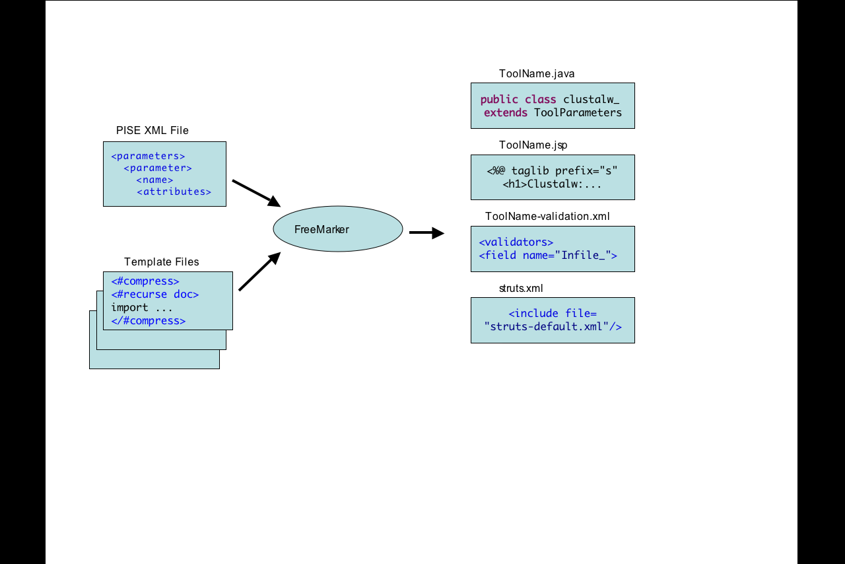

Figure 2. Description of FreeMarker use

In order to simplify the execution of the FreeMarker templates, these Templates are called with Ant. The execution of the Build.xml file can guarantee the creation of the respectful directory/subdirectory structures to be easily included in the Web application. The Build file permits also the merge of the content of existing struts.xml file with the values updates from the code generation.
The execution of this procedure will take place only one time during the development of the web application.

The source code is stored in SVN (http://nladr-cvs.sdsc.edu/svn/NGBW) under the project “codegen” which includes a README file that descirbes the content of the implementation project.

README

Project Description:
--------------------

+ FreemarkerTemplate: includes ftl templates that were designed to generate Web Artifact (JSP,Java, etc.)

+old: includes ftl templates and old build file as created by Lucie Chan for generating a similar set of Web Artifact (Html, action, Form, etc.) the content of this folder is for reference as it is not used at all in the new Code Generation procedure

+ AUTO-GENERATED/src/.../.../... : are the generated directories and files, created by running: ant build.xml

+ PiseXML: includes pise xml files for tools defintions
PiseXML/lib : contains the orignal tar files downloaded from Pise repository
PiseXML/PARSER : contains the DTD and XSD of the pise files
PiseXML/XMLDIR : contains an exception pise xml that don't define a tool but a set of common properties used by multiple pise xml

+ build.xml
ant configuration file

+ lib/struts.xml represents the file of the web application that need to be merged with the content
generated from the procedure

+lib/jar: includes the jar files called in the build.xml (XMLtask.jar and freemarker.jar)

+lib/dependency: it includes jar files as they are "import" by the generated classes, this helps to eliminate the dependencies errors in the generated classes it also includes 2 dependency files (ToolParameters.java and CreateTask.java) these 2 files are also needed to mask compilation errors from the generated classes

Unix Command Line Generation
Most of the needed and requested tools by users are command line based, in other words, these tools are executed by a Unix command line on a shell. Other set of interactive tool (not necessary command line) should be also provided but not necessary through PISE environment (example CIRIUS tool). We tried to use PISE command information in order to generate the Unix Command line.

Specification and Design
Based on user interface requirements and other element in the Swami SDK, we have to adhere to the following requirements which was not considered in PISE architecture:
- PISE permits users to enter the data files, parameters files, and parameters all at the same time in one unique interface associated to each tool. This aspect is not going to be handled similarly in SWAMI parameters interface. Indeed, user requirements impose the necessity to separate between data entering (uploading/searching) and data selection for tools. The simplest explanation is that users prefer to upload their data (sequences, structures, trees, etc.) and then select these data to be used with different tools (Figure 3). This also adhere to SWAMI mission of giving user a storage alternative form their local machine.

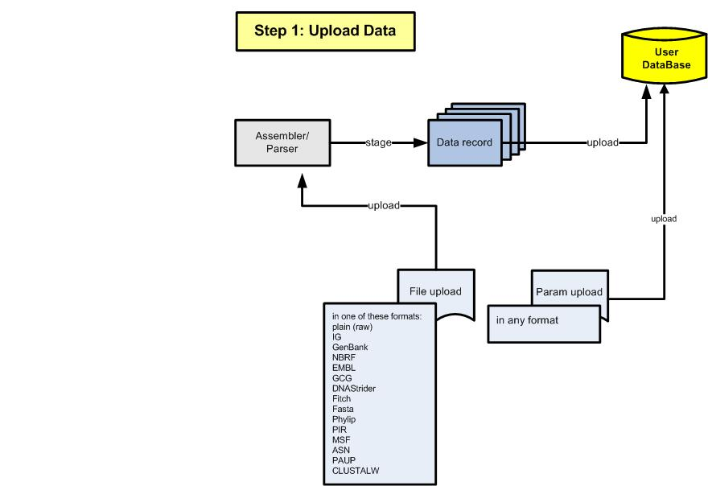
Figure 3. Step 1 (Upload Data and Parameters)

- PISE tools are called on input files, parameters files in order to generate output files. This design is not possible with SWAMI SDK, indeed, every piece of data that user is able to access in his environment is a single data record (called User Data Item, with its associated metadata biotype and datatype). Since every command line tool is going to be called on a shell with files existing on the machine, we should regroup and convert the set of User Data Item selected by the user for this tool into a “file” to be temporary stored in the file system of the machine hosting the executive of the tool. In addition, parameters files (files that are not going to be parsed to User Data Items) should also be staged on the same machine. The names of these files (input files and parameters) should be unique on the file system or grouped in a unique directory path (task run directory). The output files are also going to be created in the same environment, the name of these files should also be unique to distinguish the results of different and simultaneous calls. All these files should be removed from the file system once the execution of the tool is finished and the output captured (Figure 4).

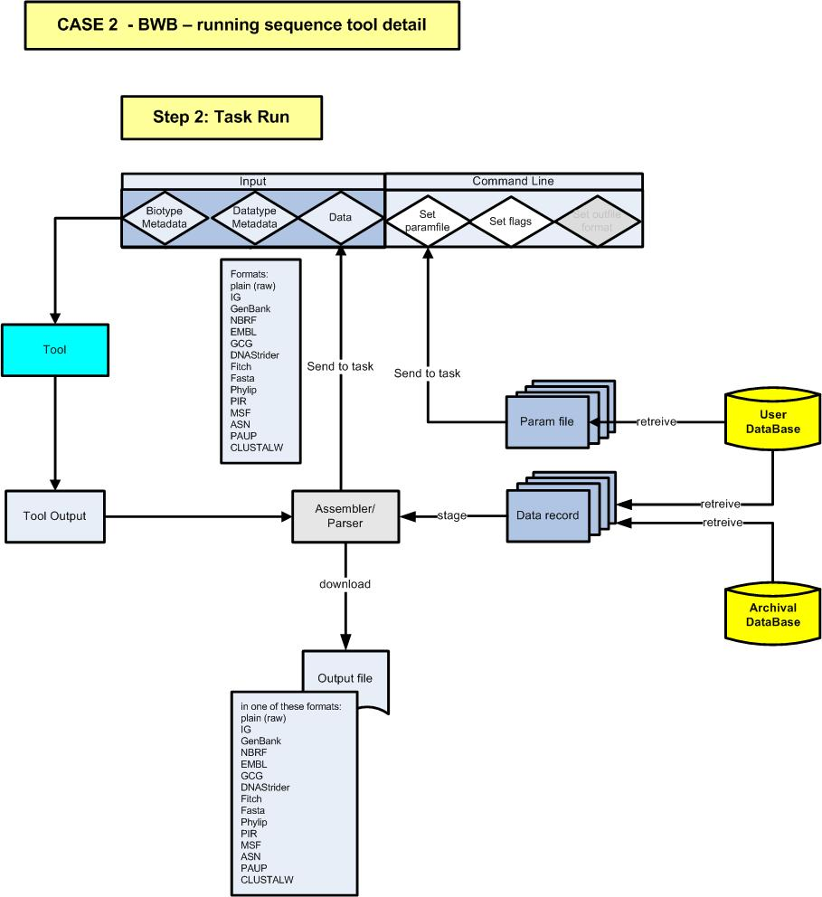
Figure 4: Description of the Execution of a tool (also called Task Run in SWAMI SDK)

- The output results can be either be parsed (if their datatype, biotype is known to SWAMI SDK) or conserved in their format in the user Database (no conversion is currently implemented form output file to User Data Item but such direction should be tackled in next release). However, in both cases the output results will be accessible to be viewed or download by the user. PISE permits users to choose format of the output in the same interface when they are entering their parameters. This option will not be conserved from PISE into SWAMI parameters interface, indeed, SWAMI gives users better flexibility in term of converting tool’s result to multiple formats and downloading them at anytime on their needs.

Implementation
The implementation of Unix Command Generation was written in JAVA (1.5) in order to be consistent with the rest of SWAMI SDK. The UML Class Diagram for this part of code is given in (Figure 5). In addition the implementation used the following elements for simplifying the code generation:

- Using JAXB Marshaller and Unmarsheller to generate PISE-based Java Classes from PISE XML’ XSD, this XSD was automatically generated from the PISE DTD (using XML Spy).
- Since most of the command line statement are bounded with preconditions written in Perl in the original PISE XML. We tried to evaluate these statements individually by calling Perl –e (perl evaluate as a separate thread in the code).
- In addition the implementation gives the users the possibility to generate a PISE XML+Values file that include all the parameters values entered by the users (Map2Pise).

Figure 5: UML Class Diagram representing the implementation of Code Generation

References:
[1] A Web Interface Generator for Molecular Biology Program in Unix, C.Letondal, Bioinformatics, Vol.17, no.1 2001, pages 73-82. http://bioinformatics.oxfordjournals.org/cgi/content/abstract/17/1/73
[2] Distributions are available @ : ftp://ftp.pasteur.fr/pub/GenSoft/unix/misc/Pise/

APPENDIX A: Errors in PISE XML 5.a (it includes 370 tools definitions):

- Directory structure: …/PARSER/pise.dtd (not a error, but it is not included in Pise-5.a-xml.tar.gz and should be searched online or extracted from Pise-5.a.tar.gz)

- Some files in the Pise directory should be in …/XMLDIR/
Since other XML files refers in their ENTITY section to these files

- These files don’t contain a tool description but common parameters used by multiple tools (those that we are aware of, and we‘ve moved them to the right directory are):
blast_init.xml
emboss.xml
fastapath.xml
gnewisepar_param.xml
glimmer_header.xml
hmmpar_param.xml
nucdbs.xml
phylip_header.xml
protdbs.xml

- 2 XML files (wise.xml , gff2pf.xml) are completely empty; it doesn’t even include XML tag

- Other errors in the content of the files are:

File Name | Parameter name | Error --> Correction
Clustalw | Gapopen(Integer) | Vdefault: 10.00-->10
 | Pairgap(Float) | Vdefault: 3--> 3.00
Pratt | Z0 (Integer) | Vdefault: 10.00 --> 10
 | Z1(Integer) | Vdefault: 10.00 --> 10
 | Z2(Integer) | Vdefault: 3.00 --> 3
 | Z3(Integer) | Vdefault: 10.00 --> 10
Prima | Minprimertm (Float) | Vdefault: 53 --> 53.00
 | Maxprimertm(Float) | Vdefault: 58 --> 58.00
 | Saltconc(Float) | Vdefault: 50 --> 50.00
 | Dnaconc(Float) | Vdefault: 50 --> 50.00
Prot_nucml | N1(Integer) | Vdefault: 4.0 --> N1(Float)
 | N2(Integer) | Vdefault: 1.0 --> N2(Float)
Protdist | Change_prob(Integer) | Vdefault: 0.4570 --> Change_prob(Float)
 | Ratio(Integer); | Vdefault: 2.000 --> Ration(Float)
Bl2seq | Searchspacesize (double) | Vdefault: 0 --> Searchspacesize(Integer)
Xpound | Cut_off(Integer) | Vdefautl: 0.75 --> Cutt_off(Float)
 | High(Integer) | Vdefautl: 0.75 --> High(Float)
 | Low(Integer) | Vdefautl: 0.5 --> Low(Float)
Buildmodel | Insconf (Float) | Vdefautl: 10000 --> 10000.00
Cirdna | Originangle(Float); | Vdefautl: 90 --> 90.00
 | Textheight(Float); | Vdefautl: 1 --> 1.00
 | Textlength(Float); | Vdefautl: 1 --> 1.00
 | Tickheight(Float); | Vdefautl: 1 --> 1.00
 | Blockheight(Float); | Vdefautl: 1 --> 1.00
 | Rangeheight(Float); | Vdefautl: 1 --> 1.00
 | Gapgroup(Float); | Vdefautl: 1 --> 1.00
 | Postext(Float); | Vdefautl: 1 --> 1.00
Clustalwpar | Gapopen(Integer) | Vdefault: 10.00-->10
 | Pairgap(Float) | Vdefault: 3-->3.00
Consensus | Standard_deviation(float); | Vdefautl: 1 --> 1.00
Dnadist | Ratio(Integer); | Vdefautl: 2.00 --> Ratio(Float);
Wublast2 | Gape (Float) | Vdefautl: 2000 --> 2000.00
Stamp | Scancut (Integer) | Vdefautl: 2.0 --> 2
Sigscan | Gapo(Float) | Vdefautl: 10 --> 10.00
Nrscope | Gapopen (Float) | Vdefautl: 10 --> 10.00
Modelfromalign | Insconf(Float) | Vdefautl: 10000 --> 10000.000.00
Merger | Gapextend(Float) | Vdefautl: 10--> 10.00
Megablastpar | Dropoff_extent (Float) | Vdefautl: 0 --> 0.00
 | Ident_cutoff(Float) | Vdefautl: 1 --> 1.00
Lindna | Textheight (Float) | Vdefautl: 1 --> 1.00
 | Textlenght(Float) | Vdefautl: 1 --> 1.00
 | Margin(Float) | Vdefautl: 1 --> 1.00
 | Tichheight(Float) | Vdefautl: 1 --> 1.00
 | Blockheight(Float) | Vdefautl: 1 --> 1.00
 | Gapgroup (Float) | Vdefautl: 1 --> 1.00
 | Postext (Float) | Vdefautl: 1 --> 1.00
 | Rang (Float) | Vdefautl: 1 --> 1.00
Kitsch | Power(Integer) | Vdefautl: 2.0 --> 2
Homology | Cycles(Float) | Vdefautl: 30 --> 30.00
Fitch | Power(Integer) | Vdefautl: 2.0 --> 2
Genemark | Threshold (Integer) | Vdefautl: 0.5 --> Threshold (Float)
Fastdnaml | Transition (Integer) | Vdefautl: 2.0 --> Transition (Float)
Hmmpfampar | Sam_adjust_score(Switch) | Vdefault:2 --> sam_adjust_score (Integer)
T_coffee | Segnos (Boolean) | Vdefault: on --> 1
Drawtreee | Xxres (Float) | Vdefautl: 500 --> 500.00
 | Xyres(Float) | Vdefautl: 500 --> 500.00
Drawgram | Xres (Float) | Vdefautl: 500 --> 500.00
 | Xres(Float) | Vdefautl: 500 --> 500.00
Hmmsearch | E_value_cutoff (Float) | Vdefautl: 10 --> 10.00
Hmmpar_parm | Sam_adjust_score(Switch) | Vdefault: 2 --> sam_adjust_score (Integer)
Genewisepar_param | Sam_adjust_score(Switch) | Vdefault:2 --> sam_adjust_score (Integer)
Primo | Oligo_file(Infile) | Vdefault: Name Oligo\noligo1 GAGGCAGGAGAATGGCAC --> “Name Oligo\noligo1 GAGGCAGGAGAATGGCAC”
Interface |  | The tool name is a java reserved --> change the name to Interface_

Separator Problem: some of the separator in PiseXML can be an empty character ‘’ ; this is not acceptable when transmitted to Java; we decided to remove separator when its value is empty character. To keep consistent we assigned as default in our program if separator is not expressed to be empty character. Here are the tools affected by this change.
Clustalw | hgapresidues | Separator ‘’ --> Removed
Msbar | 3 positions | Separator , --> ‘,’
Clustalwpar |  | Separator ‘’ --> Removed
Transeq |  | Separator , --> ‘,’
Codontree |  | Separator ‘’ --> Removed
Tcoffee | 2 positions | Separator , --> ‘,’
Siggen | 2 positions | Separator , --> ‘,’
Showseq |  | Separator , --> ‘,’
Showorf |  | Separator , --> ‘,’
lassap | 2 positions | Separator ‘" "’--> ‘ ’
Tacg |  | Separator ‘" "’--> ‘ ’

Group Issue: some tools have parameters without group value, others their group values are too high (e.g.1000) or negative (e.g -10). We added to the UnixCommandRenderer a method that can organize negative value in descending order versus the ascending order of positive value group. For missing group values, we have added the default value of the Paragraph where they are included. For high value, we made change in the PiseXML files to a value in the range of 0-99 without having confusion with other existing values. Here is the list of updates:

Clique | Group 1000 --> 99
Blast2 | Missing Group --> add default of paragraph
Psiblast | Missing Group --> add default of paragraph
dnadist | Group 100 --> 40  Group 1000 --> 50  Group 1010 --> 51  Group 1011 --> 52
dnapars | Group 1000 --> 50  Group 1010 --> 51
dollop | Group 1000 --> 99
Mix | Group 1000 --> 99
Pars | Group 1000 --> 99
Protdist | Group 1000 --> 90  Group 10000 --> 99
Protpars | Group 1000 --> 99  Group 100 --> 90
Seqboot | Group 1010 --> 99  Group 1000 --> 90

Declaration Issue:
We have removed DTD declaration form the tools under the distribution of the release 1.0
We have also removed Entity declaration and replaced it with the value that is supposed to be added to it dynamically.

Input File Issue:
As described in the SDK of the SWAMI, we separate between the input file and all the other parameters and infiles. We are not going to show in the parameters interface a box to choose/enter the input file, this process will take place in advance in SWAMI Webapp. Therefore, we have added the attribute ishidden=”1” to the PiseXML description of the input file , the name of the parameter of each tool included under release 1.0 is shown in Appendix C.
APPENDIX B: PISE XML 5.a (it includes 370 tools definitions):

aaindexextract.xml | complex.xml | est2genome.xml | hmmsearchpar.xml
abiview.xml | compseq.xml | etandem.xml | hmoment.xml
aconvert.xml | con_filter.xml | extractcds.xml | homology.xml
addquart.xml | confmat.xml | extractfeat.xml | html4blast.xml
align2model.xml | cons.xml | extractseq.xml | iep.xml
alignfit.xml | consense.xml | fasta.xml | infoalign.xml
alistat.xml | consensus.xml | fastasplitter.xml | infoseq.xml
amps.xml | corbatest.xml | fastdnaml.xml | intconv.xml
antigenic.xml | cosa.xml | fastdnamlpar.xml | interface.xml
assp.xml | cpgplot.xml | fastrna.xml | isochore.xml
avestruc.xml | cpgreport.xml | filtersites.xml | kitsch.xml
backtranseq.xml | CSR.xml | findkm.xml | lassap.xml
bambe.xml | cusp.xml | fitch.xml | lgicsearch.xml
banana.xml | cutseq.xml | fmtseq.xml | lindna.xml
bionj.xml | dan.xml | freak.xml | listor.xml
biosed.xml | dca.xml | full_run.xml | loadseq.xml
bl2seq.xml | decorate.xml | funky.xml | long_orfs.xml
blast2.xml | demoreport.xml | fuzznuc.xml | lspcalc_prosite.xml
blastpar.xml | descseq.xml | fuzzpro.xml | lspcalc_seqdb.xml
blastz.xml | dialign2.xml | fuzztran.xml | lspcalc_seqseq.xml
blimps.xml | dichet.xml | garnier.xml | lspread_prosite.xml
blimps_block.xml | diffseq.xml | gb2xml.xml | lspread_seqdb.xml
blimps_matrix.xml | digest.xml | geecee.xml | lspread_seqseq.xml
boxshade.xml | distmat.xml | genemark.xml | lvb.xml
btwisted.xml | distquart.xml | genewiseprotpar.xml | makehist.xml
build_icm.xml | dnadist.xml | genscan.xml | map.xml
buildmodel.xml | dnapars.xml | getblock.xml | marscan.xml
cai.xml | dollop.xml | getorf.xml | maskfeat.xml
cap3.xml | domainer.xml | gff2ps.xml | maskseq.xml
cds.xml | dotmatcher.xml | gibbs.xml | matcher.xml
chaos.xml | dotpath.xml | gibbs_scan.xml | megablastpar.xml
charge.xml | dottup.xml | glimmer.xml | megamerger.xml
degapseq.xml | drawgram.xml | glimmer_extract.xml | melting.xml
demoalign.xml | drawpyr.xml | golden.xml | merger.xml
checktrans.xml | drawtree.xml | grailclnt.xml | mfold.xml
chips.xml | dreg.xml | gruppi.xml | mix.xml
cirdna.xml | druid.xml | helixturnhelix.xml | mmsearch.xml
clique.xml | dsc.xml | hmmalign.xml | modelfromalign.xml
clustalw.xml | dssp.xml | hmmbuild.xml | morgan.xml
clustalw_convert.xml | dstamp.xml | hmmcalibrate.xml | most.xml
clustalwpar.xml | einverted.xml | hmmconvert.xml | mreps.xml
codcmp.xml | embossversion.xml | hmmemit.xml | msa.xml
coderet.xml | emma.xml | hmmer2sam.xml | msbar.xml
codnocod.xml | emowse.xml | hmmfetch.xml | mspcrunch.xml
codontree.xml | entret.xml | hmmpar.xml | mview_alig.xml
codonw.xml | environ.xml | hmmpfam.xml | mview_blast.xml
coils2.xml | epestfind.xml | hmmpfampar.xml | mwfilter.xml
comalign.xml | eprimer3.xml | hmmscore.xml | needle.xml
combat.xml | equicktandem.xml | hmmsearch.xml | neighbor.xml
newcoils.xml | primo.xml | seqboot.xml | titi.xml
newcpgreport.xml | prodom.xml | seqclean.xml | tmap.xml
newcpgseek.xml | profit.xml | seqgen.xml | toppred.xml
newseq.xml | prophecy.xml | seqinfo.xml | toto.xml
njdist.xml | prophet.xml | seqmatchall.xml | tranalign.xml
nnssp.xml | prose.xml | seqret.xml | transeq.xml
notseq.xml | prosearch.xml | seqretall.xml | transform.xml
nrscope.xml | prot_nucml.xml | seqretallfeat.xml | treealign.xml
nthseq.xml | protal2dna.xml | seqretset.xml | treetypedisplay.xml
octanol.xml | protdist.xml | seqretsingle.xml | trimest.xml
oddcomp.xml | protpars.xml | seqsblast.xml | trimseq.xml
palindrome.xml | pscan.xml | seqstat.xml | trnascan.xml
pam.xml | psiblast.xml | showalign.xml | twofeat.xml
parciquart.xml | psiblastpar.xml | showdb.xml | union.xml
pars.xml | psort2.xml | showfeat.xml | unroot.xml
PARSER | Puzzle.xml | showorf.xml | vectorstrip.xml
pasteseq.xml | pyramids.xml | showseq.xml | water.xml
patmatdb.xml | pyreval.xml | shuffleseq.xml | weighbor.xml
patmatmotifs.xml | qatest.xml | sig.xml | whichdb.xml
patmattest.xml | qstar.xml | sigcleave.xml | wise2.xml
patser.xml | quicktree.xml | siggen.xml | wobble.xml
pdbc.xml | readnexus.xml | sigplot.xml | wordcount.xml
pdbsearch.xml | readseq.xml | sigscan.xml | wordmatch.xml
pdbseq.xml | recoder.xml | silent.xml | wublast2.xml
pdbtosp.xml | redata.xml | sirna.xml | xblast.xml
pepcoil.xml | remap.xml | sixpack.xml | xpound.xml
pepinfo.xml | RepeatMasker.xml | skipseq.xml | yank.xml
pepnet.xml | repeats.xml | smile.xml
pepstats.xml | reputer.xml | smile2.xml
pepwheel.xml | restover.xml | sorttrans.xml
pepwindow.xml | restrict.xml | spacne.xml
pepwindowall.xml | revseq.xml | splitter.xml
Pestfind.xml | rif.xml | sputnik.xml
pftools.xml | rnadistance.xml | squizz.xml
phiblast.xml | rnaeval.xml | sreformat.xml
pima.xml | rnafold.xml | ssearch.xml
plotcon.xml | rnaga.xml | stamp.xml
plotorf.xml | rnaheat.xml | stamps.xml
plsearch.xml | rnainverse.xml | stretcher.xml
polydot.xml | rnapdist.xml | stride.xml
pratt.xml | rnasubopt.xml | stssearch.xml
predator.xml | sam2hmmer.xml | supermatcher.xml
preg.xml | sampleseqs.xml | swissparse.xml
prettyalign.xml | saps.xml | syco.xml
prettyplot.xml | satellites.xml | t_coffee.xml
prettyseq.xml | scan_for_matches.xml | tacg.xml
prima.xml | scope.xml | tcode.xml
primers.xml | scopparse.xml | tfscan.xml
primersearch.xml | screen2h.xml | tipdate.xml
APPENDIX C: PISE XML Schema Representation:

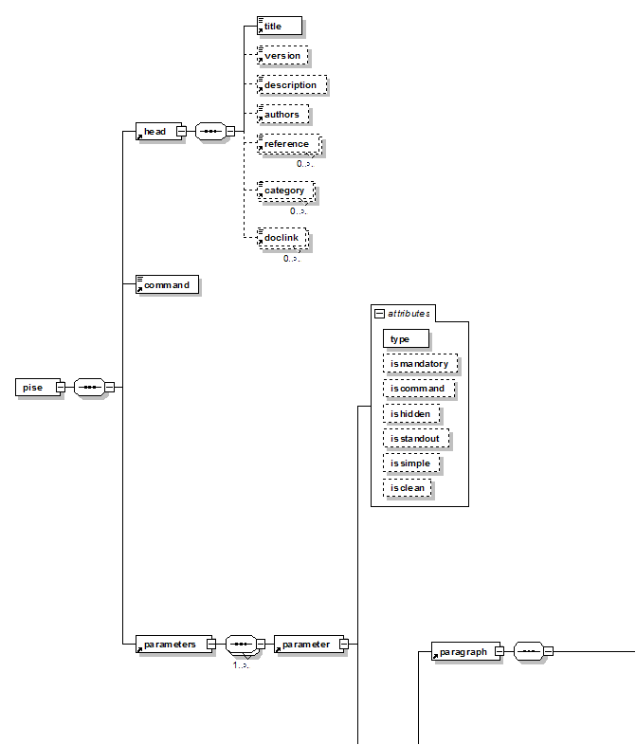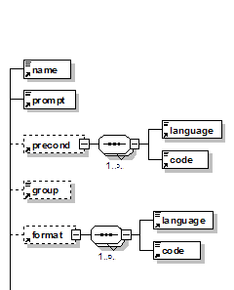
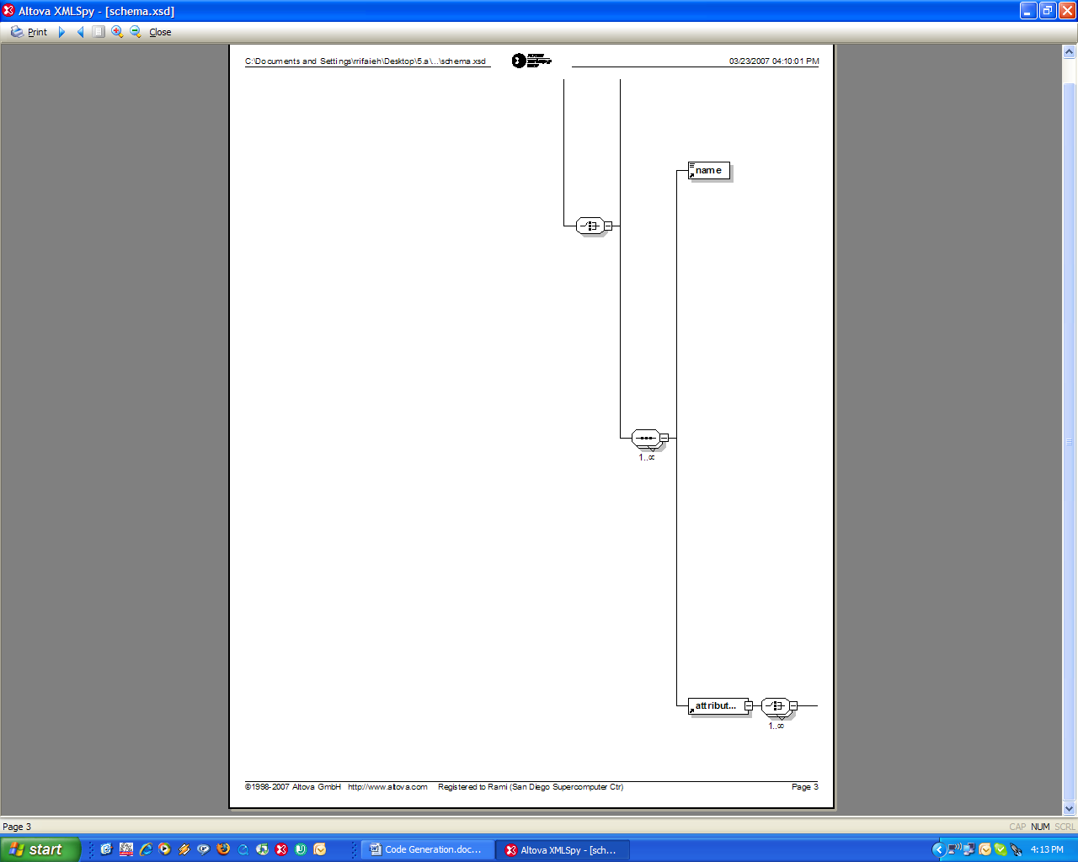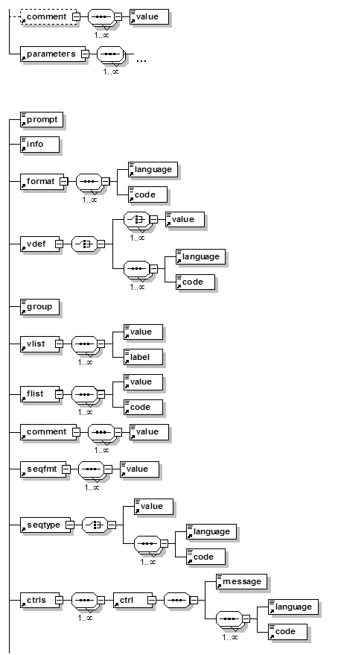
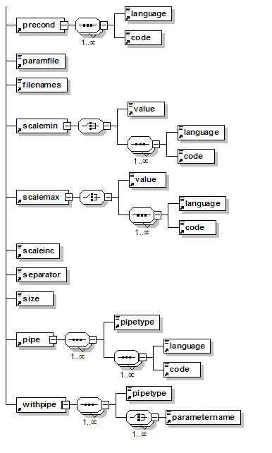
APPENDIX D: Tool’s that are going to be handled in Release 1.0 (Rows in Green are not yet decided to be in this release)

Program | Package |  | Infile | Formats | Param file | Formats | Outfile | Formats | Results | Formats
ClustalW | ClustalW | DONE | infile | Fasta | usetree | .dnd file | newtree | .dnd file | aligfile | <filenames>*.aln *.gde *.phy</filenames>
 |  |  |  | Clustal | usetree1 | .dnd file | outfile | .aln file | newtreefile | <filenames>*.phy *.msf *.pir</filenames>
 |  |  |  |  | usetree2 | .dnd file | newtree1 | .dnd file | phylipnewtreefile | <filenames>*.nj *.dst</filenames>
 |  |  |  |  | profile1 | a .aln file from clustal | newtree2 | .dnd file | readseq_ok_aligfile | <filenames>*.dnd *.ph *.phb</filenames>
 |  |  |  |  | profile2 | a .aln file from clustal | these seem to be input files
Blast2 | Blast2 | Done | query | Fasta | restrict_db | param file | seqalign_file | ASN.1 | htmlfile | html
 |  |  |  |  | psi_checkpoint | param file |  | <value>16</value> | tmp_outfile | txt
 |  |  |  |  |  |  |  |  | xmloutput | xml
PsiBlast | PsiBlast | DONE | query | Fasta |  |  | seqalign_file | ASN.1 <value>16</value> | html_file | html
 |  |  |  |  |  |  | save_matrix | paramfile (blast matrix) | txt_output | .txt
 |  |  |  |  |  |  | save_txt_matrix | paramfile (blast matrix)
 |  |  |  |  |  | 1
T_Coffee | T_Coffee | DONE | sequences | <value>8</value> fasta | parameters | param file |  |  | newtreefile | <filenames>*.nj *.dat</filenames>
 |  |  | in0 |  | tcoffee_defaults | param file |  |  | phylipnewtreefile | <filenames>*.dnd *.ph *.phb</filenames>
 |  |  | in1 |  | dali_file | param file |  |  | aligfile | <filenames>*.aln *.gds *.phylip *.clustalw_aln *.phy</filenames>
 |  |  | in2 |  | method_in0 | param file |  |  | readseq_ok_aligfile | <filenames>*.phylip *.msf *.pir_aln *.msf_aln *.phy *.pir</filenames>
 |  |  | in3 |  | method_in1 | param file |  |  | picture | <filenames>*.score_ps *.score_html *.score_pdf</filenames>
 |  |  | in4 |  | method_in2 | param file |  |  | other | <filenames>*.weight *.tc_lib *.fasta_* *.pir_seq</filenames>
 |  |  | in5 |  | method_in3 | param file
 |  |  | in6 |  | method_in4 | param file
 |  |  | in7 |  | method_in5 | param file
 |  |  | in8 |  | method_in6 | param file
 |  |  | in9 |  | method_in7 | param file
 |  |  | in10 |  | method_in8 | param file
 |  |  | in11 |  | method_in9 | param file
 |  |  | in12 |  | method_in10 | param file
 |  |  | in13 |  | method_in11 | param file
 |  |  | in14 |  | method_in12 | param file
 |  |  | in15 |  | method_in13 | param file
 |  |  | in16 |  | method_in14 | param file
 |  |  | in17 |  | method_in15 | param file
 |  |  | in18 |  | method_in16 | param file
 |  |  | in19 |  | method_in17 | param file
 |  |  |  |  | method_in18 | param file
 |  |  |  |  | method_in19 | param file
 |  |  |  |  | profile0 | param file
 |  |  |  |  | profile1 | param file
 |  |  |  |  | profile2 | param file
 |  |  |  |  | profile3 | param file
 |  |  |  |  | profile4 | param file
 |  |  |  |  | profile5 | param file
 |  |  |  |  | profile6 | param file
 |  |  |  |  | profile7 | param file
 |  |  |  |  | profile8 | param file
 |  |  |  |  | profile9 | param file
 |  |  |  |  | profile10 | param file
 |  |  |  |  | profile11 | param file
 |  |  |  |  | profile12 | param file
 |  |  |  |  | profile13 | param file
 |  |  |  |  | profile14 | param file
 |  |  |  |  | profile15 | param file
 |  |  |  |  | profile16 | param file
 |  |  |  |  | profile17 | param file
 |  |  |  |  | profile18 | param file
 |  |  |  |  | profile19 | param file
 |  |  |  |  | seq_weigth | param file
 |  |  |  |  | usetree | phylip tree
 |  |  |  |  | seq_to_align | param file
Mfold | Mfold | DONE | SEQ | <value>1</value>IG/Stanford |  |  |  |  | outfiles | <filenames>*.pnt *.plot *.ct *.html *.gif *.ps</filenames>
 |  |  |  | <value>2</value> GenBank/GB
 |  |  |  | <value>4</value> EMBL
PhyML | PhyML | Done | alignment | <value>12</value> | user_tree_file | Newick format) |  |  | outfiles | *.txt
 |  |  |  | PHYLIP |  |  |  |  | outtree_result | phylip_tree
Phylip
dnadist |  | Done | infile | <value>12</value> | weights_file | param | outfile | ASCII
 |  |  |  | PHYLIP |  |  | params | Print out the data at start of run (1)
 |  |  |  |  |  |  | tmp_params
 |  |  | type="Results"> | 3 |  |  |  |  |  | outfile
dnapars |  | Done | infile | <value>12</value> | weights_file | param | outfile | ASCII
 |  |  |  | PHYLIP | tree_file | Phyliptree | treefile | Phylip tree | Write out trees onto tree file (6)
 |  |  |  |  |  |  | indented_treefile | Indent treefile
 |  |  |  |  |  |  | params | Print out the data at start of run (1)
 |  |  |  |  |  |  | tmp_params | Print out the data at start of run (1)
 |  |  |  |  |  |  | consense_outfile
 |  |  |  |  |  |  | consense_treefile
protdist |  | Done | infile | <value>12</value> | weights_file | param | outfile | ASCII
 |  |  |  | PHYLIP |  |  | params | Print out the data at start of run (1)
 |  |  |  |  |  |  | tmp_params
protpars |  | Done | infile | <value>12</value> |  |  | outfile | ASCII
 |  |  |  | PHYLIP |  |  | treefile
 |  |  |  |  |  |  | indented_treefile
 |  |  |  |  |  |  | params
 |  |  |  |  |  |  | tmp_params
 |  |  |  |  |  |  | consense_outfile
 |  |  |  |  |  |  | consense_treefile
consense |  | Done | infile |  |  |  | outfile | ASCII
 |  |  |  |  |  |  | treefile | Phylip tree
 |  |  |  |  |  |  | indented_treefile
 |  |  |  |  |  |  | params
 |  |  |  |  |  |  | tmp_params
unroot |  | Done | treefile | Phylip tree |  |  | outree | Phylip tree
 |  |  |  |  |  |  | params
clique |  | Done | infile | <value>12</value> |  |  | outfile | ASCII
 |  |  |  | PHYLIP |  |  | treefile | Phylip tree
 |  |  |  |  |  |  | indented_treefile
 |  |  |  |  |  |  | params
 |  |  |  |  |  |  | tmp_params
 |  |  |  |  |  |  | consense_outfile
 |  |  |  |  |  |  | consense_treefile
mix |  | Done | infile | <value>12</value> | <value>tree_file</value> | Phylip tree | outfile | ASCII
 |  |  |  | PHYLIP |  |  | treefile | Phylip tree
 |  |  |  |  |  |  | indented_treefile
 |  |  |  |  |  |  | params
 |  |  |  |  |  |  | tmp_params
 |  |  |  |  |  |  | consense_outfile
 |  |  |  |  |  |  | consense_treefile
dollop |  | Done | infile | <value>12</value> | tree_file | Phylip tree | outfile | ASCII
 |  |  |  | PHYLIP |  |  | treefile | Phylip tree
 |  |  |  |  |  |  | indented_treefile
 |  |  |  |  |  |  | params
 |  |  |  |  |  |  | tmp_params
 |  |  |  |  |  |  | consense_outfile
 |  |  |  |  |  |  | consense_treefile
pars |  | Done | infile | <value>12</value> | tree_file | Phylip tree | outfile | ASCII
 |  |  |  | PHYLIP | weights_file | param | treefile | Phylip Tree
 |  |  |  |  |  |  | indented_treefile
 |  |  |  |  |  |  | params
 |  |  |  |  |  |  | tmp_params
 |  |  |  |  |  |  | consense_outfile
 |  |  |  |  |  |  | consense_treefile
seqboot |  | Done | infile | <value>12</value> |  |  | outfile | ASCII
 |  |  |  | PHYLIP |  |  | params
Boxshade |  | Done | alignment | <value>100</value> |  |  | outfile | ASCII | psfile  htmlfile  pictfile  matrixfile  tmp_params |  |  |  |  | <filenames>params *.result *.pict</filenames>
 |  |  |  | clustalw |  |  | If none of the flags is used, BOXSHADE writes in the native style of the machine it is running on.

<parameters>
<parameter>
<name>
<attributes>
<#compress>
<#recurse doc>
import ...
</#compress>
PISE XML File
Template Files
FreeMarker
ToolName.java
public class clustalw_
extends ToolParameters
ToolName.jsp
<%@ taglib prefix="s"
<h1>Clustalw:...
ToolName-validation.xml
<validators>
<field name="Infile_">
struts.xml
<include file=
"struts-default.xml"/>
PISE XML files
Registry
Web Artifact Generation
Templates
JSP, Actions, Validations
Struts.xml, etc.
Automatic Generation
Entered Parameters Values
ToolName
Select a Tool
ToolName
Get Tool PISE XML
Enters Parameters
ParamMap
Unix Command Generation
Tool PISE XML
Data Items --> Input Names
Unix Command line
List Unfinished for Emboss :

 |  |  | Infile | Formats | Param file | Formats | Outputfile | Results
aaindexextract.xml.in | 5: aaindexextract | Emboss-4.0.0 | <name>infile</name> | 1 |  | 1
abiview.xml.in | 6: abiview | Emboss-4.0.0 | <name>infile</name> | 1 |  | 1 | <name>outseq</name> | <name>psresults</name> | <name>metaresults</name>
antigenic.xml.in | 13: antigenic | Emboss-4.0.0 | <name>sequence</name> | 1 |  | 1 | <name>outfile</name>
backtranseq.xml.in | 16: backtranseq | Emboss-4.0.0 | <name>sequence</name> | 1 |  | 1 | <name>outfile</name>
banana.xml.in | 18: banana | Emboss-4.0.0 | <name>sequence</name> | 1 | <name>anglesfile</name> | 1 | <name>outfile</name> | <name>psresults</name> | <name>metaresults</name>
biosed.xml.in | 20: biosed | Emboss-4.0.0 | <name>sequence</name> | 1 |  | 1 | <name>outseq</name>
btwisted.xml.in | 29: btwisted | Emboss-4.0.0 | <name>sequence</name> | 1 |  | 1 | <name>outfile</name>
cai.xml.in | 32: cai | Emboss-4.0.0 | <name>seqall</name> | 1 |  | 1 | <name>outfile</name> |  | \
chaos.xml.in | 35: chaos | Emboss-4.0.0 | <name>sequence</name> | 1 |  | 1 | <name>outfile</name> | <name>psresults</name> | <name>metaresults</name>
charge.xml.in | 36: charge | Emboss-4.0.0 | <name>seqall</name> | 1 |  | 1 | <name>outfile</name> | <name>psresults</name> | <name>metaresults</name>
 |  |  |  |  |  | 1
checktrans.xml.in | 37: checktrans | Emboss-4.0.0 | <name>sequence</name> | 1 |  | 1 | <name>outseq</name>
 |  |  |  |  |  | 1 | <name>featout</name>
 |  |  |  |  |  | 1 | <name>outfile</name>
 |  |  |  |  |  | 1
chips.xml.in | 38: chips | Emboss-4.0.0 | <name>seqall</name> | 1 |  | 1 | <name>outfile</name>
cirdna.xml.in | 39: cirdna | Emboss-4.0.0 | <name>infile</name> | 1 |  | 1 | User can only specify the device to which output is piped. We can remove this choice. | <name>psresults</name> | <name>metaresults</name>
codcmp.xml.in | 44: codcmp | Emboss-4.0.0 | no user input allowed | 1 |  | 1 | <name>outfile</name>
coderet.xml.in | 45: coderet | Emboss-4.0.0 | <name>seqall</name> | 1 |  | 1 | <name>outseq</name>
compseq.xml.in | 53: compseq | Emboss-4.0.0 | <name>sequence</name> | 1 | <name>infile</name> | 1 | <name>outfile</name>
cons.xml.in | 56: cons | Emboss-4.0.0 | <name>sequence</name> | 1 |  | 1 | <name>outseq</name>
cpgplot.xml.in | 61: cpgplot | Emboss-4.0.0 | <name>sequence</name> | 1 |  | 1 | <name>outfile</name> | <name>psresults</name> | <name>metaresults</name>
 |  |  |  |  |  | 1 | <name>featout</name>
 |  |  |  |  |  | 1
cpgreport.xml.in | 62: cpgreport | Emboss-4.0.0 | <name>sequence</name> | 1 |  | 1 | <name>outfile</name> | <name>psresults</name>
 |  |  |  |  |  | 1 | <name>featout</name>
 |  |  |  |  |  | 1
CSR.xml.in |  | Emboss-4.0.0 | <name>pdbfile</name> | 1 |  | 1 | <name>substructure</name> | <name>param</name>
 |  |  |  |  |  | 1 |  | <name>pdb_outfile</name>
 |  |  |  |  |  | 1
cusp.xml.in | 63: cusp | Emboss-4.0.0 | <name>sequence</name> | 1 |  | 1 | <name>outfile</name>
cutseq.xml.in | 64: cutseq | Emboss-4.0.0 | <name>sequence</name> | 1 |  | 1 | <name>outseq</name>
 |  |  |  |  |  | 1
decorate.xml.in | 65: decorate | Emboss-4.0.0 | <name>pdbfile</name> |  |  | 1 | allows user to specify 1 file | <name>result_files</name>
 |  |  | <name>alignment</name> |  |  | 1 | the second is check.pdb | <name>pdb_file</name>
 |  |  |  |  |  | 1
descseq.xml.in | 71: descseq | Emboss-4.0.0 | <name>sequence</name> | 1 |  | 1 | <name>outseq</name>
 |  |  |  |  |  | 1
diffseq.xml.in | 74: diffseq | Emboss-4.0.0 | <name>asequence</name> | 1 |  | 1 | <name>outseq</name>
 |  |  | <name>bsequence</name> |  |  | 1 | <name>afeatout</name>
 |  |  |  |  |  | 1 | <name>bfeatout</name>
 |  |  |  |  |  | 1
digest.xml.in | 75: digest | Emboss-4.0.0 | <name>sequence</name> | 1 |  | 1 | <name>outfile</name>
distmat.xml.in | 76: distmat | Emboss-4.0.0 | <name>sequence</name> | 1 |  | 1 | <name>outfile</name>
 |  |  |  |  |  | 1
dotmatcher.xml.in | 82: dotmatcher | Emboss-4.0.0 | <name>asequence</name> | 1 |  | 1 | user specifies device to receive output | <name>psresults</name> | <name>metaresults</name>
 |  |  | <name>bsequence</name> |  |  | 1
 |  |  |  |  |  | 1
dotpath.xml.in | 83: dotpath | Emboss-4.0.0 | <name>asequence</name> | 1 |  | 1 | user specifies device to receive output | <name>psresults</name> | <name>metaresults</name>
 |  |  | <name>bsequence</name> |  |  | 1
 |  |  |  |  |  | 1
dottup.xml.in | 84: dottup | Emboss-4.0.0 | <name>asequence</name> | 1 |  | 1 | user specifies device to receive output | <name>psresults</name> | <name>metaresults</name>
 |  |  | <name>bsequence</name> |  |  | 1
 |  |  |  |  |  | 1
dreg.xml.in | 88: dreg | Emboss-4.0.0 | <name>sequence</name> | 1 |  | 1 | <name>outfile</name>
einverted.xml.in | 93: einverted | Emboss-4.0.0 | <name>sequence</name> | 1 |  | 1 | <name>outfile</name>
embossversion.xml.in | 94: embossversion | Emboss-4.0.0 |  |  |  | 1 | <name>outfile</name> | this tool can be dropped
 |  |  |  |  |  | 1
emma.xml.in | 95: emma | Emboss-4.0.0 | <name>sequence</name> | 1 |  | 1 | <name>outseq</name>
 |  |  |  |  |  | 1 | <name>dendoutfile</name>
 |  |  |  |  |  | 1
emowse.xml.in | 96: emowse | Emboss-4.0.0 | <name>sequence</name> | 1 | <name>infile</name> | 1 | <name>outfile</name>
entret.xml.in | 97: entret | Emboss-4.0.0 | <name>sequence</name> | 1 |  | 1 | <name>outfile</name>
epestfind.xml.in | 99: epestfind | Emboss-4.0.0 | <name>sequence</name> | 1 |  | 1 | <name>outfile</name> | <name>psresults</name> | <name>metaresults</name>
 |  |  |  |  |  | 1
eprimer3.xml.in | 100: eprimer3 | Emboss-4.0.0 | <name>sequence</name> | 1 | <name>mispriminglibrary</name> | 1 | <name>outfile</name>
 |  |  |  |  | <name>oligomishyblibrary</name> | 1
 |  |  |  |  |  | 1
equicktandem.xml.in | 101: equicktandem | Emboss-4.0.0 | <name>sequence</name> | 1 |  | 1 | <name>outfile</name>
 |  |  |  |  |  | 1 | <name>origfile</name>
 |  |  |  |  |  | 1
est2genome.xml.in | 102: est2genome | Emboss-4.0.0 | <name>est</name> | 1 |  | 1 | <name>outfile</name>
 |  |  | <name>genome</name> |  |  | 1
 |  |  |  |  |  | 1
etandem.xml.in | 103: etandem | Emboss-4.0.0 | <name>sequence</name> | 1 |  | 1 | <name>outfile</name>
 |  |  |  |  |  | 1 | <name>origfile</name>
 |  |  |  |  |  | 1
extractfeat.xml.in | 105: extractfeat | Emboss-4.0.0 | <name>sequence</name> | 1 |  | 1 | <name>outseq</name>
extractseq.xml.in | 106: extractseq | Emboss-4.0.0 | <name>sequence</name> | 1 |  | 1 | <name>outseq</name>
findkm.xml.in | 113: findkm | Emboss-4.0.0 | <name>infile</name> | 1 |  | 1 | <name>outfile</name> | <name>psresults</name> | <name>metaresults</name>
freak.xml.in | 116: freak | Emboss-4.0.0 | <name>seqall</name> | 1 |  | 1 | <name>outfile</name> | <name>psresults</name> | <name>metaresults</name>
fuzznuc.xml.in | 119: fuzznuc | Emboss-4.0.0 | <name>sequence</name> | 1 |  | 1 | <name>outfile</name>
fuzzpro.xml.in | 120: fuzzpro | Emboss-4.0.0 | <name>sequence</name> | 1 |  | 1 | <name>outfile</name>
fuzztran.xml.in | 121: fuzztran | Emboss-4.0.0 | <name>sequence</name> | 1 |  | 1 | <name>outfile</name>
garnier.xml.in | 122: garnier | Emboss-4.0.0 | <name>sequencea</name> | 1 |  | 1 | <name>outfile</name>
geecee.xml.in | 124: geecee | Emboss-4.0.0 | <name>sequence</name> | 1 |  | 1 | <name>outfile</name>
getorf.xml.in | 128: getorf | Emboss-4.0.0 | <name>sequence</name> | 1 |  | 1 | <name>outseq</name>
helixturnhelix.xml.in | 137: helixturnhelix | Emboss-4.0.0 | <name>sequence</name> | 1 |  | 1 | <name>outfile</name>
hmoment.xml.in | 150: hmoment | Emboss-4.0.0 | <name>seqall</name> | 1 |  | 1 | <name>outfile</name> | <name>psresults</name> | <name>metaresults</name>
iep.xml.in | 153: iep | Emboss-4.0.0 | <name>sequence</name> | 1 |  | 1 | <name>outfile</name> | <name>psresults</name> | <name>metaresults</name>
infoalign.xml.in | 154: infoalign | Emboss-4.0.0 | <name>sequence</name> | 1 |  | 1 | <name>outfile</name>
infoseq.xml.in | 155: infoseq | Emboss-4.0.0 | <name>sequence</name> | 1 |  | 1 | <name>outfile</name>
isochore.xml.in | 158: isochore | Emboss-4.0.0 | <name>sequence</name> | 1 |  | 1 | <name>outfile</name> | <name>psresults</name> | <name>metaresults</name>
lindna.xml.in | 162: lindna | Emboss-4.0.0 | <name>sequence</name> | 1 |  | 1 | user pipes output to graphic device | <name>psresults</name> | <name>metaresults</name>
 |  |  |  | 1 |  | 1
listor.xml.in | 163: listor | Emboss-4.0.0 | <name>firstset</name> | 1 |  | 1 | <name>outfile</name>
 |  |  | <name>secondset</name> | 1 |  | 1
 |  |  |  | 1 |  | 1
marscan.xml.in | 175: marscan | Emboss-4.0.0 | <name>sequence</name> | 1 |  | 1 | <name>outfile</name>
maskfeat.xml.in | 176: maskfeat | Emboss-4.0.0 | <name>sequence</name> | 1 |  | 1 | <name>outseq</name>
maskseq.xml.in | 177: maskseq | Emboss-4.0.0 | <name>sequence</name> | 1 |  | 1 | <name>outseq</name>
 |  |  |  | 1 |  | 1
matcher.xml.in | 178: matcher | Emboss-4.0.0 | <name>asequence</name> | 1 |  | 1 | <name>outfile</name>
 |  |  | <name>bsequence</name> | 1 |  | 1
 |  |  |  | 1 |  | 1
megamerger.xml.in | 180: megamerger | Emboss-4.0.0 | <name>asequence</name> | 1 |  | 1 | <name>outseq</name>
 |  |  | <name>bsequence</name> | 1 |  | 1 | <name>outfile</name>
 |  |  |  | 1 |  | 1
merger.xml.in | 182: merger | Emboss-4.0.0 | <name>asequence</name> | 1 |  | 1 | <name>outseq</name>
 |  |  | <name>bsequence</name> | 1 |  | 1 | <name>outfile</name>
 |  |  |  | 1 |  | 1
msbar.xml.in | 191: msbar | Emboss-4.0.0 | <name>sequence</name> | 1 |  | 1 | <name>outseq</name>
 |  |  | <name>othersequence</name> | 1 |  | 1
 |  |  |  | 1 |  | 1
mwfilter.xml.in | 195: mwfilter | Emboss-4.0.0 | <name>sequence</name> | 1 | <name>datafile</name> | 1 | <name>outfile</name>
needle.xml.in | 196: needle | Emboss-4.0.0 | <name>infile</name> | 1 | <name>tolerance</name> | 1 | <name>outfile</name>
newcpgreport.xml.in | 199: newcpgreport | Emboss-4.0.0 | <name>sequence</name> | 1 |  | 1 | <name>outfile</name>
newcpgseek.xml.in | 200: newcpgseek | Emboss-4.0.0 | <name>sequence</name> | 1 |  | 1 | <name>outfile</name>
newseq.xml.in | 201: newseq | Emboss-4.0.0 | <name>sequence</name> | 1 |  | 1 | <name>outseq</name>
 |  |  |  | 1 |  | 1
notseq.xml.in | 204: notseq | Emboss-4.0.0 | <name>sequence</name> | 1 |  | 1 | <name>outseq</name>
 |  |  |  | 1 |  | 1 | <name>junkoutseq</name>
 |  |  |  | 1 |  | 1
nthseq.xml.in | 206: nthseq | Emboss-4.0.0 | <name>sequence</name> | 1 |  | 1 | <name>outseq</name>
octanol.xml.in | 207: octanol | Emboss-4.0.0 | <name>sequence</name> | 1 | <name>datafile</name> | 1 | user pipes output to graphic device | <name>psresults</name> | <name>metaresults</name>
oddcomp.xml.in | 208: oddcomp | Emboss-4.0.0 | <name>sequence</name> | 1 | <name>compdatafile</name> | 1 | <name>outfile</name>
palindrome.xml.in | 209: palindrome | Emboss-4.0.0 | <name>sequence</name> | 1 |  | 1 | <name>outfile</name>
 |  |  |  | 1 |  | 1
pasteseq.xml.in | 213: pasteseq | Emboss-4.0.0 | <name>asequence</name> | 1 |  | 1 | <name>outseq</name>
 |  |  | <name>bsequence</name> | 1 |  | 1
 |  |  |  | 1 |  | 1
patmatdb.xml.in | 214: patmatdb | Emboss-4.0.0 | <name>sequence</name> | 1 |  | 1 | <name>outfile</name>
patmatmotifs.xml.in | 215: patmatmotifs | Emboss-4.0.0 | <name>sequence</name> | 1 |  | 1 | <name>outfile</name>
pepcoil.xml.in | 222: pepcoil | Emboss-4.0.0 | <name>sequence</name> | 1 |  | 1 | <name>outfile</name>
pepinfo.xml.in | 223: pepinfo | Emboss-4.0.0 | <name>sequence</name> | 1 |  | 1 | <name>outfile</name> | <name>psresults</name> | <name>metaresults</name>
pepnet.xml.in | 224: pepnet | Emboss-4.0.0 | <name>sequence</name> | 1 |  | 1 | user pipes output to graphic device | <name>psresults</name> | <name>metaresults</name>
pepstats.xml.in | 225: pepstats | Emboss-4.0.0 | <name>sequence</name> | 1 |  | 1 | <name>outfile</name>
pepwheel.xml.in | 226: pepwheel | Emboss-4.0.0 | <name>sequence</name> | 1 |  | 1 | user pipes output to graphic device | <name>psresults</name> | <name>metaresults</name>
pepwindow.xml.in | 227: pepwindow | Emboss-4.0.0 | <name>sequence</name> | 1 | <name>datafile</name> | 1 |  | <name>psresults</name> | <name>metaresults</name>
pepwindowall.xml.in | 228: pepwindowall | Emboss-4.0.0 | <name>sequences</name> | 1 | <name>datafile</name> | 1 |  | <name>psresults</name> | <name>metaresults</name>
plotcon.xml.in | 233: plotcon | Emboss-4.0.0 | <name>sequences</name> | 1 |  | 1 | user pipes output to graphic device | <name>psresults</name> | <name>metaresults</name>
plotorf.xml.in | 234: plotorf | Emboss-4.0.0 | <name>sequence</name> | 1 |  | 1 | user pipes output to graphic device | <name>psresults</name> | <name>metaresults</name>
polydot.xml.in | 236: polydot | Emboss-4.0.0 | <name>sequences</name> | 1 |  | 1 | user pipes output to graphic device | <name>psresults</name> | <name>metaresults</name>
preg.xml.in | 239: preg | Emboss-4.0.0 | <name>sequence</name> | 1 |  | 1 | <name>outfile</name>
prettyplot.xml.in | 241: prettyplot | Emboss-4.0.0 | <name>sequences</name> | 1 |  | 1 | <name>outfile</name> | <name>psresults</name> | <name>metaresults</name>
prettyseq.xml.in | 242: prettyseq | Emboss-4.0.0 | <name>sequence</name> | 1 |  | 1 | <name>outfile</name>
primersearch.xml.in | 245: primersearch | Emboss-4.0.0 | <name>seqall</name> | 1 | <name>primersfile</name> | 1 | <name>outfile</name>
profit.xml.in | 247: profit | Emboss-4.0.0 | <name>sequence</name> | 1 |  | 1 | <name>outfile</name>
prophecy.xml.in | 248: prophecy | Emboss-4.0.0 | <name>sequence</name> | 1 |  | 1 | <name>outfile</name>
prophet.xml.in | 249: prophet | Emboss-4.0.0 | <name>sequence</name> | 1 |  | 1 | <name>outfile</name>
pscan.xml.in | 256: pscan | Emboss-4.0.0 | <name>sequence</name> | 1 |  | 1 | <name>outfile</name>
recoder.xml.in | 267: recoder | Emboss-4.0.0 | <name>sequence</name> | 1 |  | 1 | <name>outfile</name>
redata.xml.in | 268: redata | Emboss-4.0.0 | <name>sequence</name> | 1 |  | 1 | <name>outfile</name> | Redata allows free text entry of a restiction enzyme name. We must replace this tool; or add the data in drop down list.
remap.xml.in | 269: remap | Emboss-4.0.0 | <name>sequence</name> | 1 |  | 1 | <name>outfile</name>
restover.xml.in | 272: restover | Emboss-4.0.0 | <name>sequence</name> | 1 |  | 1 | <name>outfile</name>
restrict.xml.in | 273: restrict | Emboss-4.0.0 | <name>sequence</name> | 1 |  | 1 | <name>outfile</name>
revseq.xml.in | 274: revseq | Emboss-4.0.0 | <name>sequence</name> | 1 |  | 1 | <name>outseq</name>
seqmatchall.xml.in | 295: seqmatchall | Emboss-4.0.0 | <name>sequence</name> | 1 |  | 1 | <name>outfile</name>
seqret.xml.in | 296: seqret | Emboss-4.0.0 | <name>sequence</name> | 1 |  | 1 | <name>outseq</name>
showalign.xml.in | 303: showalign | Emboss-4.0.0 | <name>sequence</name> | 1 |  | 1 | <name>outfile</name>
showdb.xml.in | 304: showdb | Emboss-4.0.0 |  | 1 |  | 1 | <name>outfile</name> | Tool can be eliminated
showfeat.xml.in | 305: showfeat | Emboss-4.0.0 | <name>sequence</name> | 1 |  | 1 | <name>outfile</name>
showorf.xml.in | 306: showorf | Emboss-4.0.0 | <name>sequence</name> | 1 |  | 1 | <name>outfile</name>
showseq.xml.in | 307: showseq | Emboss-4.0.0 | <name>sequence</name> | 1 |  | 1 | <name>outfile</name>
shuffleseq.xml.in | 308: shuffleseq | Emboss-4.0.0 | <name>sequence</name> | 1 |  | 1 | <name>outseq</name>
sigcleave.xml.in | 310: sigcleave | Emboss-4.0.0 | <name>sequence</name> | 1 |  | 1 | <name>outfile</name>
silent.xml.in | 314: silent | Emboss-4.0.0 | <name>sequence</name> | 1 |  | 1 | <name>outfile</name>
 |  |  |  | 1 |  | 1
sirna.xml.in | 315: sirna | Emboss-4.0.0 | <name>sequence</name> | 1 |  | 1 | <name>outfile</name>
 |  |  |  | 1 |  | 1 | <name>outseq</name>
 |  |  |  | 1 |  | 1
sixpack.xml.in | 316: sixpack | Emboss-4.0.0 | <name>sequence</name> | 1 |  | 1 | <name>outfile</name>
 |  |  |  | 1 |  | 1 | <name>outseq</name>
 |  |  |  | 1 |  | 1
skipseq.xml.in | 317: skipseq | Emboss-4.0.0 | <name>sequence</name> | 1 |  | 1 | <name>outseq</name>
splitter.xml.in | 322: splitter | Emboss-4.0.0 | <name>sequence</name> | 1 |  | 1 | <name>outseq</name>
 |  |  |  | 1 |  | 1
stretcher.xml.in | 329: stretcher | Emboss-4.0.0 | <name>asequence</name> | 1 |  | 1 | <name>outfile</name>
 |  |  | <name>bsequence</name> | 1 |  | 1
 |  |  |  | 1 |  | 1
stride.xml.in | 330: stride | Emboss-4.0.0 | <name>pdbfile</name> | 1 |  | 1 | User flags specify results files | <name>molscript_file</name>
 |  |  |  | 1 |  | 1 |  | <name>outfile</name>
 |  |  |  | 1 |  | 1
stssearch.xml.in | 331: stssearch | Emboss-4.0.0 | <name>seqall</name> | 1 |  | 1 | <name>outfile</name>
supermatcher.xml.in | 332: supermatcher | Emboss-4.0.0 | <name>asequence</name> | 1 |  | 1 | <name>outfile_aformat</name>
 |  |  | <name>bsequence</name> | 1 |  | 1 | <name>errorfile</name>
 |  |  |  | 1 |  | 1
syco.xml.in | 334: syco | Emboss-4.0.0 | <name>sequence</name> | 1 |  | 1 | <name>outfile</name>
tcode.xml.in | 337: tcode | Emboss-4.0.0 | <name>sequence</name> | 1 |  | 1 | user names outfile/specifies output device | <name>psresults</name> | <name>metaresults</name>
tfscan.xml.in | 338: tfscan | Emboss-4.0.0 | <name>sequence</name> | 1 |  | 1 | <name>outfile</name>
tmap.xml.in | 341: tmap - stand alone and emboss-4.0.0 - DONE note emboss ver dominates | Emboss-4.0.0 | <name>sequences</name> | 1 |  | 1 | <name>outfile</name>
 |  |  |  | 1 |  | 1
tranalign.xml.in | 343: tranalign | Emboss-4.0.0 | <name>asequence</name> | 1 |  | 1 | <name>outseq</name>
 |  |  | <name>bsequence</name> | 1 |  | 1
 |  |  |  | 1 |  | 1
transeq.xml.in | 344: transeq | Emboss-4.0.0 | <name>sequence</name> | 1 |  | 1 | <name>outseq</name>
trimest.xml.in | 348: trimest | Emboss-4.0.0 | <name>sequence</name> | 1 |  | 1 | <name>outseq</name>
trimseq.xml.in | 349: trimseq | Emboss-4.0.0 | <name>sequence</name> | 1 |  | 1 | <name>outseq</name>
twofeat.xml.in | 351: twofeat | Emboss-4.0.0 | <name>sequence</name> | 1 |  | 1 | <name>outfile</name>
union.xml.in | 352: union | Emboss-4.0.0 | <name>sequence</name> | 1 |  | 1 | <name>outseq</name>
 |  |  |  | 1 |  | 1
vectorstrip.xml.in | 354: vectorstrip | Emboss-4.0.0 | <name>sequence</name> | 1 |  | 1 | <name>outfile</name>
 |  |  |  | 1 |  | 1 | <name>outseq</name>
 |  |  |  | 1 |  | 1
water.xml.in | 355: water | Emboss-4.0.0 | <name>asequence</name> | 1 |  | 1 | <name>outfile</name>
 |  |  | <name>bsequence</name> | 1 |  | 1
 |  |  |  | 1 |  | 1
whichdb.xml.in | 357: whichdb | Emboss-4.0.0 |  | 1 |  | 1 | <name>outfile</name> | This tool can be eliminated
wobble.xml.in | 359: wobble | Emboss-4.0.0 | <name>sequence</name> | 1 |  | 1 | <name>outfile</name>
wordcount.xml.in | 360: wordcount | Emboss-4.0.0 | <name>sequence</name> | 1 |  | 1 | <name>outfile</name>
 |  |  |  | 1 |  | 1
wordmatch.xml.in | 361: wordmatch | Emboss-4.0.0 | <name>asequence</name> | 1 |  | 1 | <name>outfile</name>
 |  |  | <name>bsequence</name> | 1 |  | 1 | <name>afeatout</name>
 |  |  |  |  |  | 1 | <name>bfeatout</name>
1. in plain (raw) sequence format or in one of the following known formats: IG,GenBank,NBRF,EMBL,GCG,DNAStrider,Fitch,fasta,Phylip,PIR,MSF,ASN,PAUP,CLUSTALW
2. user flags output:
 |  |  | <value>fasta</value>
 |  |  | <value>gcg</value>
 |  |  | <value>phylip</value>
 |  |  | <value>embl</value>
 |  |  | <value>swiss</value>
 |  |  | <value>ncbi</value>
 |  |  | <value>nbrf</value>
 |  |  | <value>genbank</value>
 |  |  | <value>ig</value>
 |  |  | <value>codata</value>
 |  |  | <value>strider</value>
 |  |  | <value>acedb</value>
 |  |  | <value>staden</value>
 |  |  | <value>text</value>
 |  |  | <value>fitch</value>
 |  |  | <value>msf</value>
 |  |  | <value>clustal</value>
 |  |  | <value>phylip</value>
 |  |  | <value>phylip3</value>
 |  |  | <value>asn1</value>

